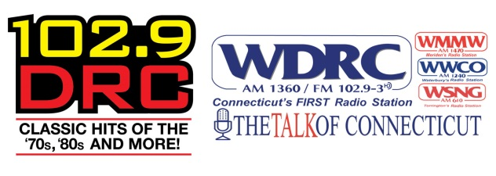
FULL-TIME OPPORTUNITY
CONNECTICUT Promotions Director-WDRC FM & Talk of Connecticut

Connoisseur Media is a broadcast media company that delivers quality radio to listeners, advertisers and communities. Connoisseur is noted as one of the top 20 radio broadcasters in the United States, according to BIA. In the past 18 months we have grown exponentially from a company of approximately 200 employees to nearly 500 today. This is an exciting time to be in the Radio Broadcasting industry and to be a part of Connoisseur Media. Our commitment to our community, employees and clients is what makes us special.

Connoisseur Media’s WDRC FM and Talk of Connecticut, is looking for a creative, detail oriented individual to be our next Promotions Director.

POSITION OVERVIEW:
Candidate should be experienced in all aspects of promotion and marketing and will be responsible for the creation, management and oversight of promotions for our radio stations in the Hartford market. The ideal person must be passionate about promotion, social media, radio and must be experienced in developing ideas that generate results for clients.

The Promotions Director will be expected to build, maintain and direct an effective marketing strategy and grass roots promotional effort within the Hartford, CT market on behalf of WDRC FM & Talk of Connecticut. In addition, this position will require collaboration with other Connecticut Connoisseur stations to coordinate and assist in regional event opportunities and to help grow the entire platform in the Connecticut region.

The Promotions Director will be an integral part of the Hartford, Connecticut group and will be expected to contribute positively with the local team to assist in the overall success and profitability of Connoisseur Media CT.

POSITION REQUIREMENTS:
- Minimum of 3 years marketing/promotions experience, preferably within the field of media.
- Successfully organize, direct & motivate the Hartford promotional effort.
- Ability to demonstrate creative thinking.
- Capability to assist in growing & maintaining client relationships to enhance the effectiveness of their advertising.
- Proficiency in communicating effectively.
- Work weekends and nights, as required.
- Must have a current and valid driver’s license.
- Demonstrate professional appearance and demeanor.
- Ability to lift heavy items

POSITION DUTIES (To include but not limited to):
- Oversee all contesting and event marketing.
- Run the social media output of the radio station including Twitter, Facebook and Instagram.
- Manage appearances at all sales and station remote broadcasts and events.
- Scheduling and hiring part time marketing staff (Street Team).
- Responsible for the overall look and feel of all events with the station’s brand in mind, as well as client and programming relations, including banner placement and location set-up.
- Maintain all on-air and web based station contests including contest rules and records of winners. Collect prizes from sales, provide copy to programming for on-air use, contact winners, and arrange for prize delivery.
- Maintain station inventory of prizes and collateral materials.
- Work with Southern CT Promotions Department for major station events, seminars, expos, etc
- Coordinate with the Digital Content Director for on-air/on-line station promotions, blog postings, creative content, and web driven contesting.
- Secure copy from clients and event sponsors for on-air station promotional announcements, scripts, ad-libs, and recorded promos.
- Write compelling articles & blogs as needed for station websites.
- Research and assemble recap reports to support sales for clients involved in station promotions.
- Extend the WDRC brand to secondary materials, promotional pieces (key chains, shirts, etc.) and station banners.
- Participation in weekly promotions meetings.
- Manage Connoisseur Hartford intern program in accordance with rules associated with internships.
- Coordinate with business department for all invoices, purchase orders, and talent payment.
- Maintain detailed and accurate records of invoices and purchase orders.
- Work closely with our NTR Department on client fulfillment as it relates to event marketing.
- Build, maintain & grow relationships with local charities, non-profit organizations and other local organizations.
- Ensure contests are conducted in accordance with FCC regulations.

We offer a competitive salary, benefits, retirement plan and paid-time-off. If you are a qualified candidate please send your resume and salary requirements to keith.dakin@connoisseurct.com with “Promotions Manager candidate” in the subject line.

Connoisseur Media, LLC provides equal employment opportunities (EEO) to all employees and applicants for employment without regard to race, color, religion, gender, sexual orientation, national origin, age, disability, marital status, amnesty, or status as a covered veteran in accordance with federal, state and local laws.

